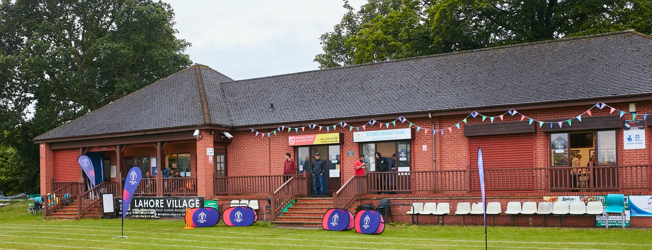

RISK ASSESSMENT TEMPLATE FOR CLUBS PREPARING TO OPEN THEIR CLUBHOUSE

Risk Assessment Template
As a facility provider, you should complete your own COVID-19 Risk Assessment and publish this to your users.

If you are not the facility provider, then you should consider which sections will apply to your clubs individual situation upon returning to play and complete a risk assessment based on your activity, including (but not limited to) people management and communication, hygiene and first aid. You may still wish to record that you have assessed facility risks through enquiries made with your facility provider.

We have provided an example risk assessment below, which is for illustrative purposes only, and includes some examples of things to consider. Consider how this will apply to each aspect of your operation and identify the controls you require to meet Government guidance regarding health, social distancing and hygiene etc. Remember that you must review your other Health and Safety, and Safeguarding, risk assessments for other hazards such as fire, first aid etc.

What are the hazards? |  | Transmission of COVID-19
Who might be harmed? |  | Facility users, staff, volunteers, visitors and the wider community
No | Controls required |  | Action Taken by the Club
People Management and Communication
 | Self-screening of individuals before they arrive at the venue to ensure individuals displaying COVID-19 symptoms or those who should be shielding do not travel or attend. |  | ACTION 1: Local club procedures to be revised and circulated to all players, club officials, scorers and junior parents on playing under ECB roadmap. These will include the requirement to self-screen if symptoms are displayed or self-isolate if required.  ACTION 2: Abridged information sheet for all visiting players and officials describing relevant local facility procedures to be revised. This is to be published on the club website and circulated to opposition captains prior to the match.  A sign is displayed at the entrance to the ground stating that individuals with COVID-19 symptoms or those required to self-isolate should not enter the ground. These will be supplemented with further signs on the football field entrances on matchdays.
 | An assessment of user numbers, space capacities, venue circulation and layout planning to maintain social distancing. |  | Pavilion is to remain closed to participants and visitors under the 1st 2 phases of ECB roadmap (until at least 17th May) therefore only outdoor areas to consider. A lone person may be present in the pavilion to organize refreshments on matchdays. Signage is displayed on the pavilion door, which is to remain locked wherever possible.  Segregated areas have been identified for participants and visitors so the primary residual risks are potential pinch points on site.  Entry/exit points are not expected to form major pinch points and therefore one-way systems are not thought to be of benefit:  - The site has 4/5 points of entry on both sides of the ground.  - 4 of these points are on the side of the ground next to the main parking areas.  - Visitor attendance is not expected to be high on matchdays and is likely limited primarily to the families of participants.  The Western Lane entrance close to the pavilion has a narrow opening when a single gate is opened. While it is not expected that foot traffic through this gate will be heavy, there may be difficulties maintaining 2m distancing. Therefore the requirement to open both gates on matchdays will be included in the club Step 4 procedures.  A facility opening checklist has been prepared – this includes the requirement to open gates on matchdays.
 | A plan for where parents and players will sit whilst watching cricket activities. |  | Segregated areas have been allocated for participants and spectators.
 | Signage and communication so that all participants and visitors are aware of the control measures in place and how to act appropriately to minimise the risk of transmission of COVID-19. |  | ACTION 3: Information to be circulated to all players, club officials, scorers and junior parents will include the requirements of the ECB roadmap guidelines on maintaining social distancing.  ACTION 4: Abridged information sheet for all visiting players and officials to be revised - this is to be published on the club website and circulated to opposition captains prior to the match.
 | Staff and volunteer training to support the implementation of the plan, with suitable training records. |  | All club officials responsible for the opening of the facility on a matchday have been trained in the use of the checklist.
Buildings
 | Assess ventilation in your building (natural and mechanical) and take appropriate measures to maximise ventilation and minimise risk of transmission. |  | Not applicable - main pavilion to remain closed. A lone person may enter the pavilion during games to organize refreshments for players or to replenish stocks for the outdoor refreshments stand.
 | Assess the maximum occupancy of your rooms at 2m social distancing (or 1m with risk mitigation where 2m is not possible) and establish a suitable circulation system/one-way system. Use signage and floor markings to communicate this. |  | Not applicable – see above.
 | Assess the arrangement of seating areas to maintain social distancing and minimise the risk of transmission. |  | Not applicable – see above.
 | Consider your wet weather plans and describe what actions you will take to maintain social distancing in wet weather. |  | Main pavilion to remain closed. Signage displayed stating pavilion closed.  ACTION 5: Procedures for circulation (see above) to include instructions on wet weather arrangements. In accordance with ECB guidelines, this will be to return to cars if insufficient outdoor shelter to maintain social distancing requirements.  Gazebos have been purchased to allow sufficient space for storage of kit bags and socially-distanced shelter for those players without cars in the event mixed weather is forecast.  Facility opening checklist includes requirement to erect sufficient outdoor shelter.
Social and Hospitality Areas
 | Plan to solicit and maintain records of your member attendance, customers and visitors - to be maintained for 21 days and then destroyed. |  | Register has been prepared to record names and contact details of all participants and officials (including opposition).  Facility opening checklist includes requirement to complete register.
 | Identification of suitable areas for outdoor service that don’t overlap with cricket activity. |  | Suitable area has been identified – a trestle table will be placed across the open pavilion doors.
 | Steps taken to minimise time and the number of people at the bar. |  | ACTION 6: Signage to be prepared to control queuing for refreshment stand
 | Steps taken to minimise contact points at payment or around the hospitality space. |  | ACTION 7 : Measures to reduce contact at payment to be introduced for refreshment stand.
 | Suitable PPE provision and training for staff and volunteers. |  | ACTION 8: PPE to be made available for volunteers running refreshment stand.  ACTION 9: Training to be given to volunteers on required PPE and behaviours when serving customers at the outdoor stand.
 | Strategy for the safe serving, clearing and cleaning of glassware and tableware. |  | Not applicable – pavilion to remain closed. Outdoor stand only
 | Deep cleaning strategy to minimise COVID-19 transmission risk |  | Not applicable – pavilion to remain closed. Outdoor stand only.
 | Daily cleaning strategy to minimise COVID-19 transmission risk. |  | Procedures in place include requirement for toilet areas to be cleaned after every match and practice during which they have been used.  Facility opening checklist includes the requirement to clean toilets after use on matchdays.
 | High-frequency touchpoint cleaning strategy to minimise COVID-19 transmission risk and how you will keep records. |  | Touchpoints have been identified for hourly cleaning and included in the club COVID information pack.  Facility opening checklist includes the requirement to assign touchpoint cleaning to suitable volunteers prior to the match.
Hygiene and Cleaning
 | Materials, PPE and training that you have provided to your staff for effective cleaning. |  | Sufficient supplies of cleaning materials are on site to allow thorough cleaning of toilet areas.  Sufficient supplies of disinfectant and/or wipes are on site to allow touchpoint disinfection.  Facility opening checklist includes the requirement to check stocks of cleaning materials and disinfectants.
 | Provision of hand washing facilities with warm water, soap, disposable towels and bin. |  | Hand towels have been replaced with paper towel dispensers. Bins have been placed to allow disposal of paper towels.  Sufficient stocks of handwash materials are on site to allow thorough handwashing for all participants and visitors.  Facility opening checklist includes the requirement to check stocks of handwash and paper towels.
 | Provision of suitable hand sanitiser in locations around the facility to maintain frequent hand sanitisation. |  | Sanitizer dispensers purchased. To be placed in player shelter areas and/or on the boundary for hygiene breaks.  Facility opening checklist includes the requirement to ensure sanitizer is available.
 | Provision of suitable wipes and hand sanitiser on the field for hygiene breaks. |  | Packs of disinfectant wipes available for ball and equipment sanitization. To be placed on the boundary for hygiene breaks.  Facility opening checklist includes the requirement to ensure disinfectant wipes are available.
 | What are the hazards? | Other venue hazards to be considered after temporary closure such as Legionnaire’s Disease, fire, electrical safety etc.
 | Who might be harmed? | Facility users, staff, volunteers and visitors
 | Controls required |  | Action Taken by the Club
Preparing Your Buildings
 | Consider the risk of Legionnaire’s disease and carry out necessary work to make your water supply safe for users. Refer to the specific guidance in the document above. |  | Groundsman has been on site through the spring and water supply has been in use.
 | Check that routine maintenance has not been missed and certification is up to date (e.g. Gas safety, Electrical Safety and Portable Appliance Testing, Fire Safety, Lifts and Heating – Ventilation and Air Conditioning). |  | No gas supply, no HVAC, no lifts.
 | Check that your ground is ready and safe to play. Look at what work is required and how this can be done safely at a social distance. |  | Ground is safe and at an appropriate stage of pitch preparation. No work appears to be required that cannot be done whilst maintaining social distance.
 | What are the hazards? | Vital first aid equipment is not available when needed. First aiders do not have adequate PPE to carry out first aid when required.
 | Who might be harmed? | First aiders, facility users, staff, volunteers and visitors
 | Controls required |  | Action Taken by the Club
First Aid
 | Check that your first aid kits are stocked and accessible during all activity. |  | First aid kit has been checked and is complete.  Facility opening checklist includes removal of kit from pavilion prior to each game if keyholder playing.
 | What steps have you taken to improve your first aiders’ understanding of first aid provision under COVID-19? |  | ACTION 10: Information on 1st aid under COVID to be circulated to all club first-aiders.
 | If you have an AED then check that it is in working order, service is up to date and that it is available during all activity. |  | Not applicable – no AED at the club
 | What are the hazards? | Pitches or outfield are unsafe to play on
 | Who might be harmed? | Players, officials, ground staff
 | Controls required |  | Action Taken by the Club
Preparing your Grounds
 | Safety checks on machinery, sightscreens and covers. |  | Not applicable – groundsman has been on site throughout the spring. Mechanical machinery has been serviced. Sightscreens are in usable condition. No covers.
 | Check and repair of any damage to pitches and outfields. |  | Groundsman has been on site throughout the spring and no damage to pitches. Broken drain has resulted in soft part of outfield but cannot be repaired until ground hardens later in the season and will need a specialist contractor.
 | Surfaces checked and watering regime adjusted based on lack of rainfall. |  | Not applicable – groundsman has been on site throughout the spring.

ACTION PLAN

NUMBER | ACTION REQUIRED | DATE COMPLETED
1,3,5 | Local club procedures on COVID guidelines to be revised and circulated to all players, club officials, scorers and junior parents on playing under the early phases of the ECB roadmap guidelines.
2,4,5 | Abridged information sheet for all visiting players and officials describing relevant local facility procedures to be revised and published on the club website.
6 | Signage to be prepared to control queuing for outdoor refreshment stand
7 | Measures to reduce contact at payment to be introduced for refreshment stand.
8 | PPE to be made available for volunteers running refreshment stand.
9 | Training to be given to volunteers on required PPE and behaviours when serving customers at the outdoor stand.
10 | Information on 1st aid under COVID to be circulated to all club first-aiders.

